**SPSS Practical 12:**

As shown in the following table, parametric data has an underlying normal distribution which allows for more conclusions to be drawn as the shape can be mathematically described. Anything else is non-parametric.

|  |  |  |
| --- | --- | --- |
|  | **Parametric** | **Non-parametric** |
| Assumed distribution | [Normal](http://www.syque.com/improvement/Normal%20distribution.htm) | Any |
| Assumed variance | [Homogeneous](http://changingminds.org/explanations/research/analysis/variance_homogeneity.htm) | Any |
| Typical data | [Ratio](http://changingminds.org/explanations/research/measurement/types_data.htm#rat) or [Interval](http://changingminds.org/explanations/research/measurement/types_data.htm#int) | [Ordinal](http://changingminds.org/explanations/research/measurement/types_data.htm#ord) or [Nominal](http://changingminds.org/explanations/research/measurement/types_data.htm#nom) |
| Data set relationships | Independent | Any |
| Usual central measure | [Mean](http://syque.com/improvement/Average.htm) | [Median](http://syque.com/improvement/Median.htm) |
| Benefits | Can draw more conclusions | Simplicity; Less affected by outliers |
| **Tests** |  |  |
| Choosing | [Choosing parametric test](http://changingminds.org/explanations/research/analysis/choose_parametric.htm) | [Choosing a non-parametric test](http://changingminds.org/explanations/research/analysis/choose_nonparametric.htm) |
| Correlation test | [Pearson](http://changingminds.org/explanations/research/analysis/pearson.htm) | [Spearman](http://changingminds.org/explanations/research/analysis/spearman.htm) |
| Independent measures, 2 groups | [Independent-measures t-test](http://changingminds.org/explanations/research/analysis/independent_measures_t-test.htm) | [Mann-Whitney test](http://changingminds.org/explanations/research/analysis/mann-whitney.htm) |
| Independent measures, >2 groups | One-way, independent-measures [ANOVA](http://changingminds.org/explanations/research/analysis/anova.htm) | Kruskal-Wallis test |
| Repeated measures, 2 conditions | [Matched-pair t-test](http://changingminds.org/explanations/research/analysis/paired_t-test.htm) | Wilcoxon test |
| Repeated measures, >2 conditions | One-way, repeated measures [ANOVA](http://changingminds.org/explanations/research/analysis/anova.htm) | Friedman's test |

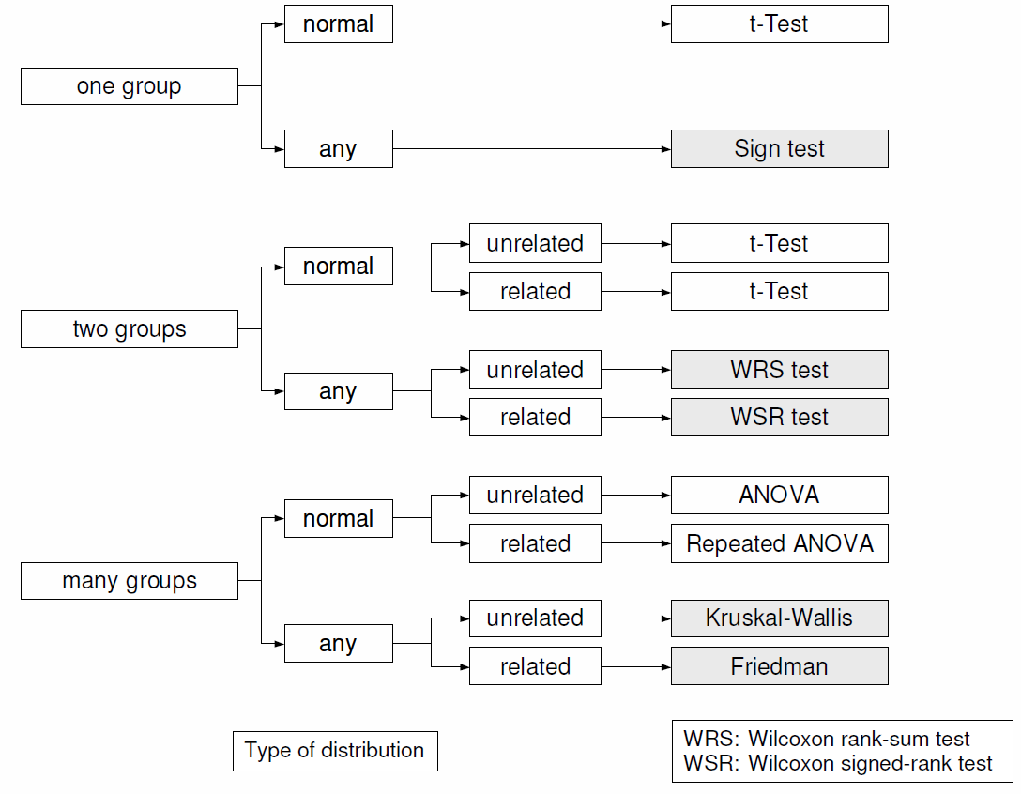

Perform the following non-parametric tests:

1. Mann-Whitney Test (Wilcoxon rank-sum Test)
$$H_{0}:Two populations have identical distribution functions$$

$$H_{1}:Two populations have distribution functions$$

$$differ only with respect to location (median)$$

2. Wilcoxon signed-rank Test
$$H_{0}:median=0$$

$$H_{1}:median≠0$$

3. Kruskal-Wallis
$$H_{0}:All populations have identical distribution functions$$

$$H_{1}:At least two populations have distribution functions$$

$$differ only with respect to location (median)$$

4. Friedman Test

$$H_{0}:All populations with the same median.$$

$$H_{1}:At least two populations with different median.$$